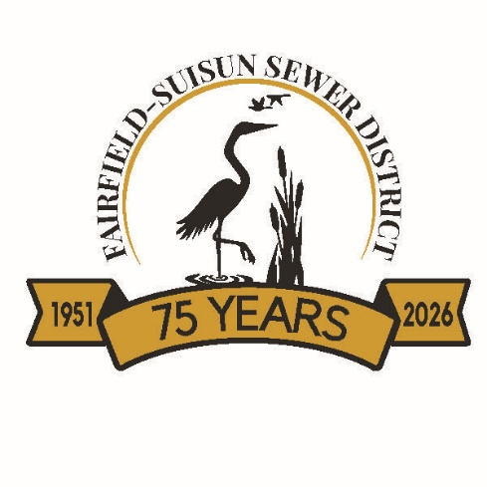

Proposition 218 Protest to Fairfield-Suisun Sewer District’s Proposed 5-Year Rate Schedule
If a property owner/customer wished to protest the proposed sewer rates, this protest must be fully completed to constitute a valid protest. Only one protest per parcel will be counted.
If a property owner/customer also wishes to potentially file a judicial challenge or other proceeding to contest the rates, then property owner/customer must also timely complete and submit a separate written objection.
PLEASE PRINT LEGIBLY OR YOUR PROTEST MAY NOT BE COUNTED
Property owner or Customer Name:_______________________________________________________
Assessor’s Parcel Number:_______________________________________________________________
Or
Property Address:______________________________________________________________________
______
Property Owner or Customer protests proposed rates or charges (check box if applicable)
Property Owner or Customer:
Signature:_____________________________________________________Date:___________________

Mail to:
Director of Administrative Services
Fairfield-Suisun Sewer District
1010 Chadbourne Road, Fairfield, CA 94534

Email to:
Scanned copies of written protests containing all required items above including the original signature, may be emailed to contactus@fairfieldsuisunsewer.ca.gov. Fax will not be accepted.

