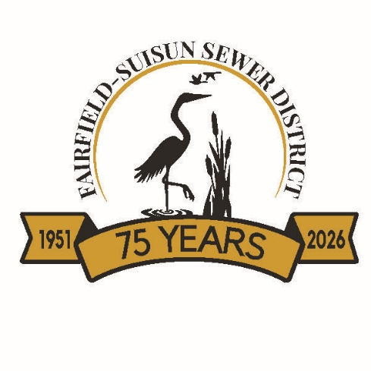

PROPOSITION 218 WRITTEN OBJECTION FORM

REQUIREMENTS:
Each part of this form must be filled out completely. Written legal objections must be submitted no later than 5:00 PM on March 26, 2026.

(Please note the date for written legal objections is EARLIER than the deadline for protests.)

To be considered timely and valid, a written legal objection must:

- Be in writing with an original signature from the property owner OR the tenant responsible for paying the sewer bill (the account holder).
- Identify the parcel for which the legal objection is filed, by street address OR the Assessor’s Parcel Number (APN).
- Clearly state that the communication is a “written objection.”
- Describe the basis for the objection with sufficient specificity to allow the District to respond in writing.

Important note: A statement such as “these rates violate Proposition 218”, without supporting explanation, is not sufficient. The objection should, where possible, cite the specific constitutional provision, statute, or regulation believed to be violated (for example, “California Const., art. XIII D, § 6(b)(3)” or “Gov. Code § 53755”).

- Include the desired resolution or outcome.
- Be received by the District by no later than 5:00 p.m., on March 26, 2026.

Mail to:
Director of Administrative Services
Fairfield-Suisun Sewer District
1010 Chadbourne Road, Fairfield, CA 94534

Email to:
Scanned copies of written legal objections containing all required items above including the original signature, may be emailed to contactus@fairfieldsuisunsewer.ca.gov. Fax will not be accepted.

PROPOSITION 218 WRITTEN OBJECTION FORM

Name of Property Owner or Customer
_________________________________________________________

Owner or Customer’s Address
(Must be subject to proposed sewer rates)

APN of Property:

- Describe the provision(s) of law that form the basis of your objection, with specific reference to statutes, rules, constitutional provisions, regulations, and/or cases that are alleged to be violated if the proposed sewer rates are adopted. (Attach additional pages as necessary.)

- Describe, with reference to your property and usage of sewer services, how the proposed sewer rates violate the provisions of law you cited above. (Attach additional pages as necessary.)

- Describe how the Fairfield-Suisun Sewer District may correct the violations of law you alleged above. Provide amendments to the proposed sewer rates and the written basis (i.e., the 2025 Cost of Service and Rate Study Report) for the sewer rates. (Attach additional pages as necessary.)

Signature __________________________________________________________

Print Name __________________________________________________________

Date _________________________________________________________________

Additional Pages (Optional)
(Please number your responses)

